Use-Case Realization Report
View Page

Issue <1.0>
Revision History
Date | Issue | Description | Author
12/10/09 | 1.0 | Initial Version | Rajendran Kumaraguru

Table of Contents
1. Brief Description 4
2. Flow of Events 4
2.1 Standard Flow 4
2.2 Exception Flow 4
3. Interaction Diagrams 4
3.1 Collaboration Diagram for View Page 4
4. Participating Objects 4
5. Class Diagrams 4
5.1 Class Diagram for View Page 4
6. Derived Requirements 5

Use-Case Realization Report
View Page

Brief Description
Portal admin will be able to view the pages which are already created for particular company.

Flow of Events

Standard Flow
- Portal Admin log into the system, and go to Page Admin Page.
- Click the view page to get the detail of particular page.
- Load the page details
- Get the page details
- Validate field validates the input values.
- Get page info will fetch the details from entity object.
- Page will be shown to portal admin

Exception Flow
- If the validation is failed then exception will be shown to portal admin
- If the requested page is not available in the system will throw the exception to portal admin

Interaction Diagrams

Collaboration Diagram for View Page
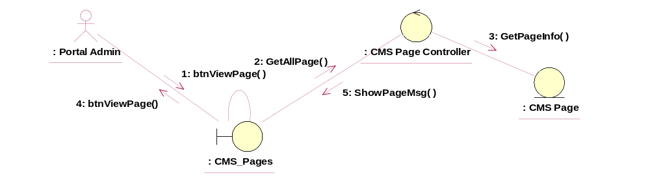

Participating Objects
: CMS_Pages
This entity is the page object which will be used in JMD while creating the new pages after creating the outline.
: CMS_Page_Controller
This is the controller to add,modify,delete and view the page information.
: CMS_Page
This object will be storing the page information.

Class Diagrams

Class Diagram for View Page
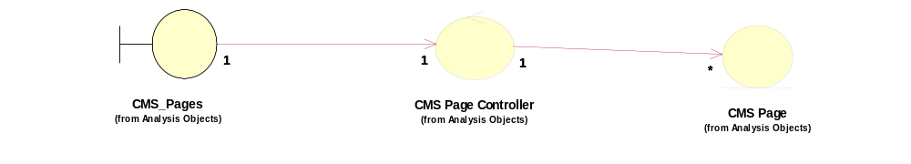

Derived Requirements
[enter the derived requirements here]

